LOCATION INFORMATION:

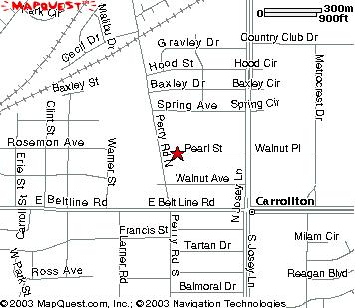

Address: C-FB ISD Adult Education
1820 Pearl St, Building C

Carrollton, TX 75006
Tel: 972 – 323 – 8822

GENERAL INFORMATION:
All tutoring for this year's program will be courtesy of the Sunray Youth Organization. For details please contact:

Alison Tan at atan75025@yahoo.com, or
Zin Fan at principal@sunraychinese.org

SCHEDULE
Offered Every Tuesday/Thursday 6:00-9:00 P.M.
Begins September 30, 2008
Ends December 18, 2008

TUTORING COMMITTEE TEAM
Chairman: Katherine Wee
Co-Chair: Jacqueline Lim, Karen Chen
Tuesday Captain: Jessica Hong
Thursday Captain: Justin Wu

SUBJECTS
Helps student on Homework and Mathematics, English, Social Studies, Social Sciences, Science, or any other extracurricular activities that we may provide help in.

ELIGIBILITY
This CFB Tutoring Association is open to CFB-ISD Adult Education program students-their children. Student must be enrolled in sixth grade or lower to be eligible for our tutoring services.

Student APPLICATION FORM

Name (first /Last) ___________________________________
Gender (circle one): F M
Email:___________________________________________
Home Phone:____________________Cell:__________________
Birth date:_________________ Grade: _______________ School:____________________________________________
Date will attend weekly: Mon______, Tue_____, Wed_____, Thu_____

Carrollton-Farmers Branch ISD
Tutoring Association

Tuesday, September 30, 2008

to

Thursday, December 18, 2008

The purpose of the Carrollton-Farmers Branch Tutoring Association is to provide academic support, enhance one’s studies, heighten one’s wisdom, and strive to develop crucial analytical skills throughout the community.
Partnership: C-FB I.S.D. Adult Education Program
Sun Ray Chinese School at Carrollton

Sponsored by:
Sun Ray School – Youth Organization
North Texas Youth Honor Society
The Sun Ray School is a non-profit private school, which admits students of any creed, race, color, nationality & ethnic origin.

